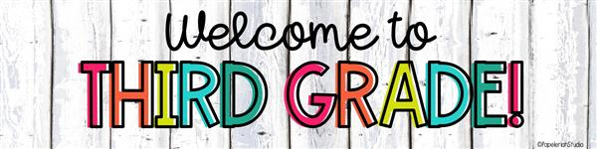

**Here is a list of supplies that they’ll need throughout the year:**

* 1 – **MOST IMPORTANT-**Pair of **USB** headphones (for student’s personal laptop use at school)- Many of the students do not have working audio jacks and these headphones will be used daily, so USB is a must
* 1 - Refillable water bottle with secure/no-spill lid- we have filtered water in the classroom
* 2 - Packs #2 pencils* (wood please-no plastic coated)
* 2 - Black composition notebook

**Community supplies (please donate at least one of these for the class):**

* Tissue Boxes*
* Clorox/Lysol Disinfecting Wipes*
* Hand Sanitizer*

**Extra community items that will be helpful:**

* Ziplock bags (sandwich or gallon size)*
* Dry snacks (Goldsfish, etc)*

*There is no need to buy additional school supplies such as notebooks, folders, pencil cases, composition books, etc. During the first week of school, I will provide them with a big eraser, folders and the writing notebook that they need. My goal is to keep it streamlined and simple!*

*We will be collecting supplies the entire first week of school. Any way that you can contribute to our classroom will be greatly appreciated! We will make sure every student has the necessary materials to ensure a successful year! (*items with an asterisk will be shared)*

**Thank you!**